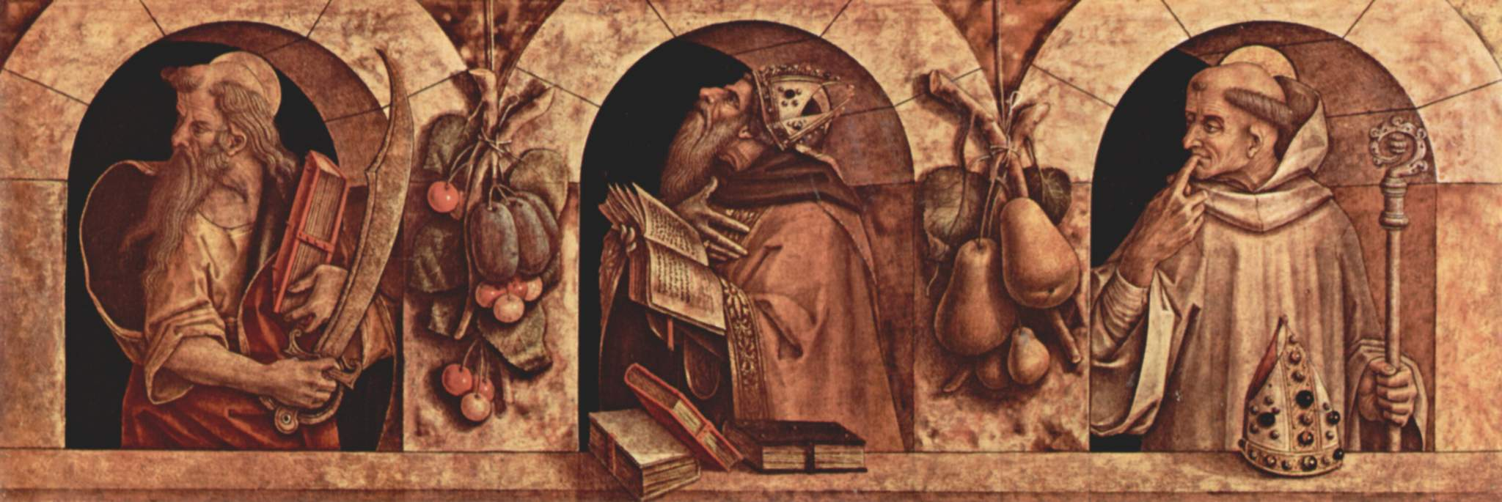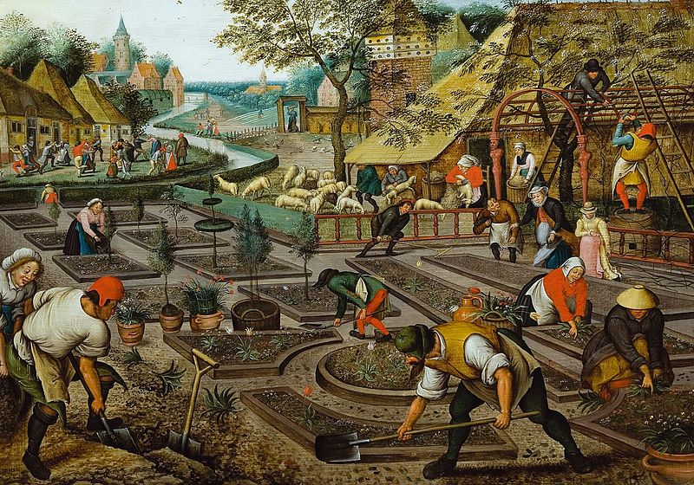 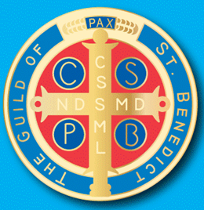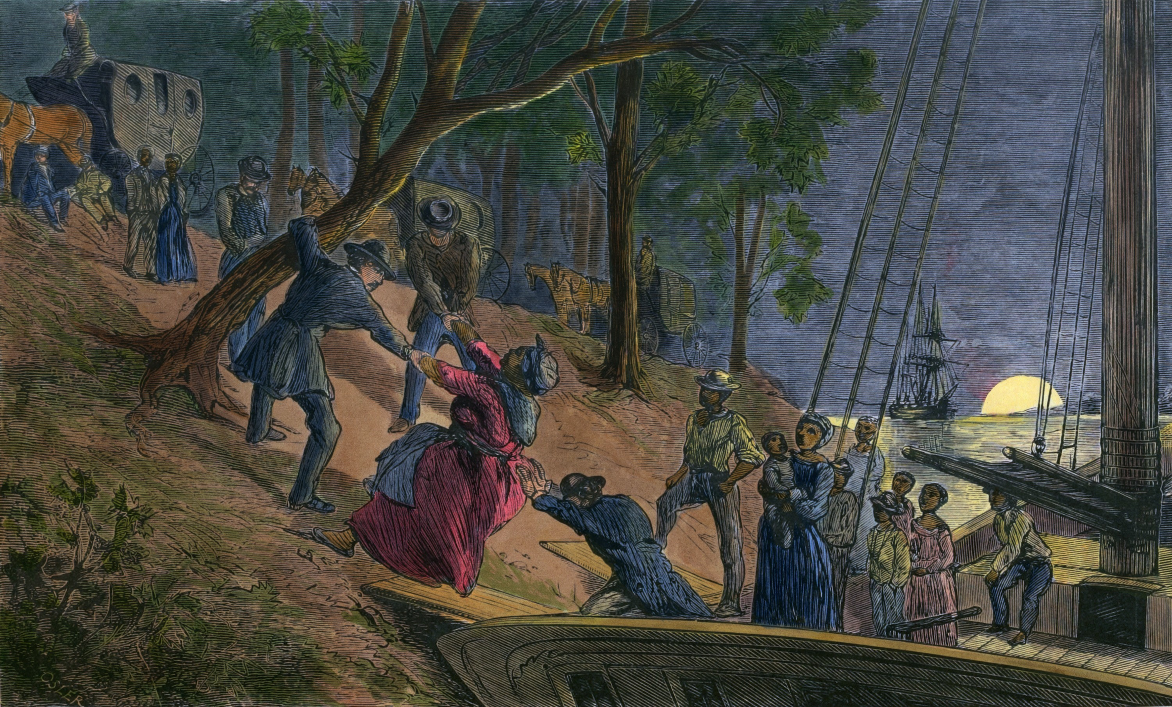 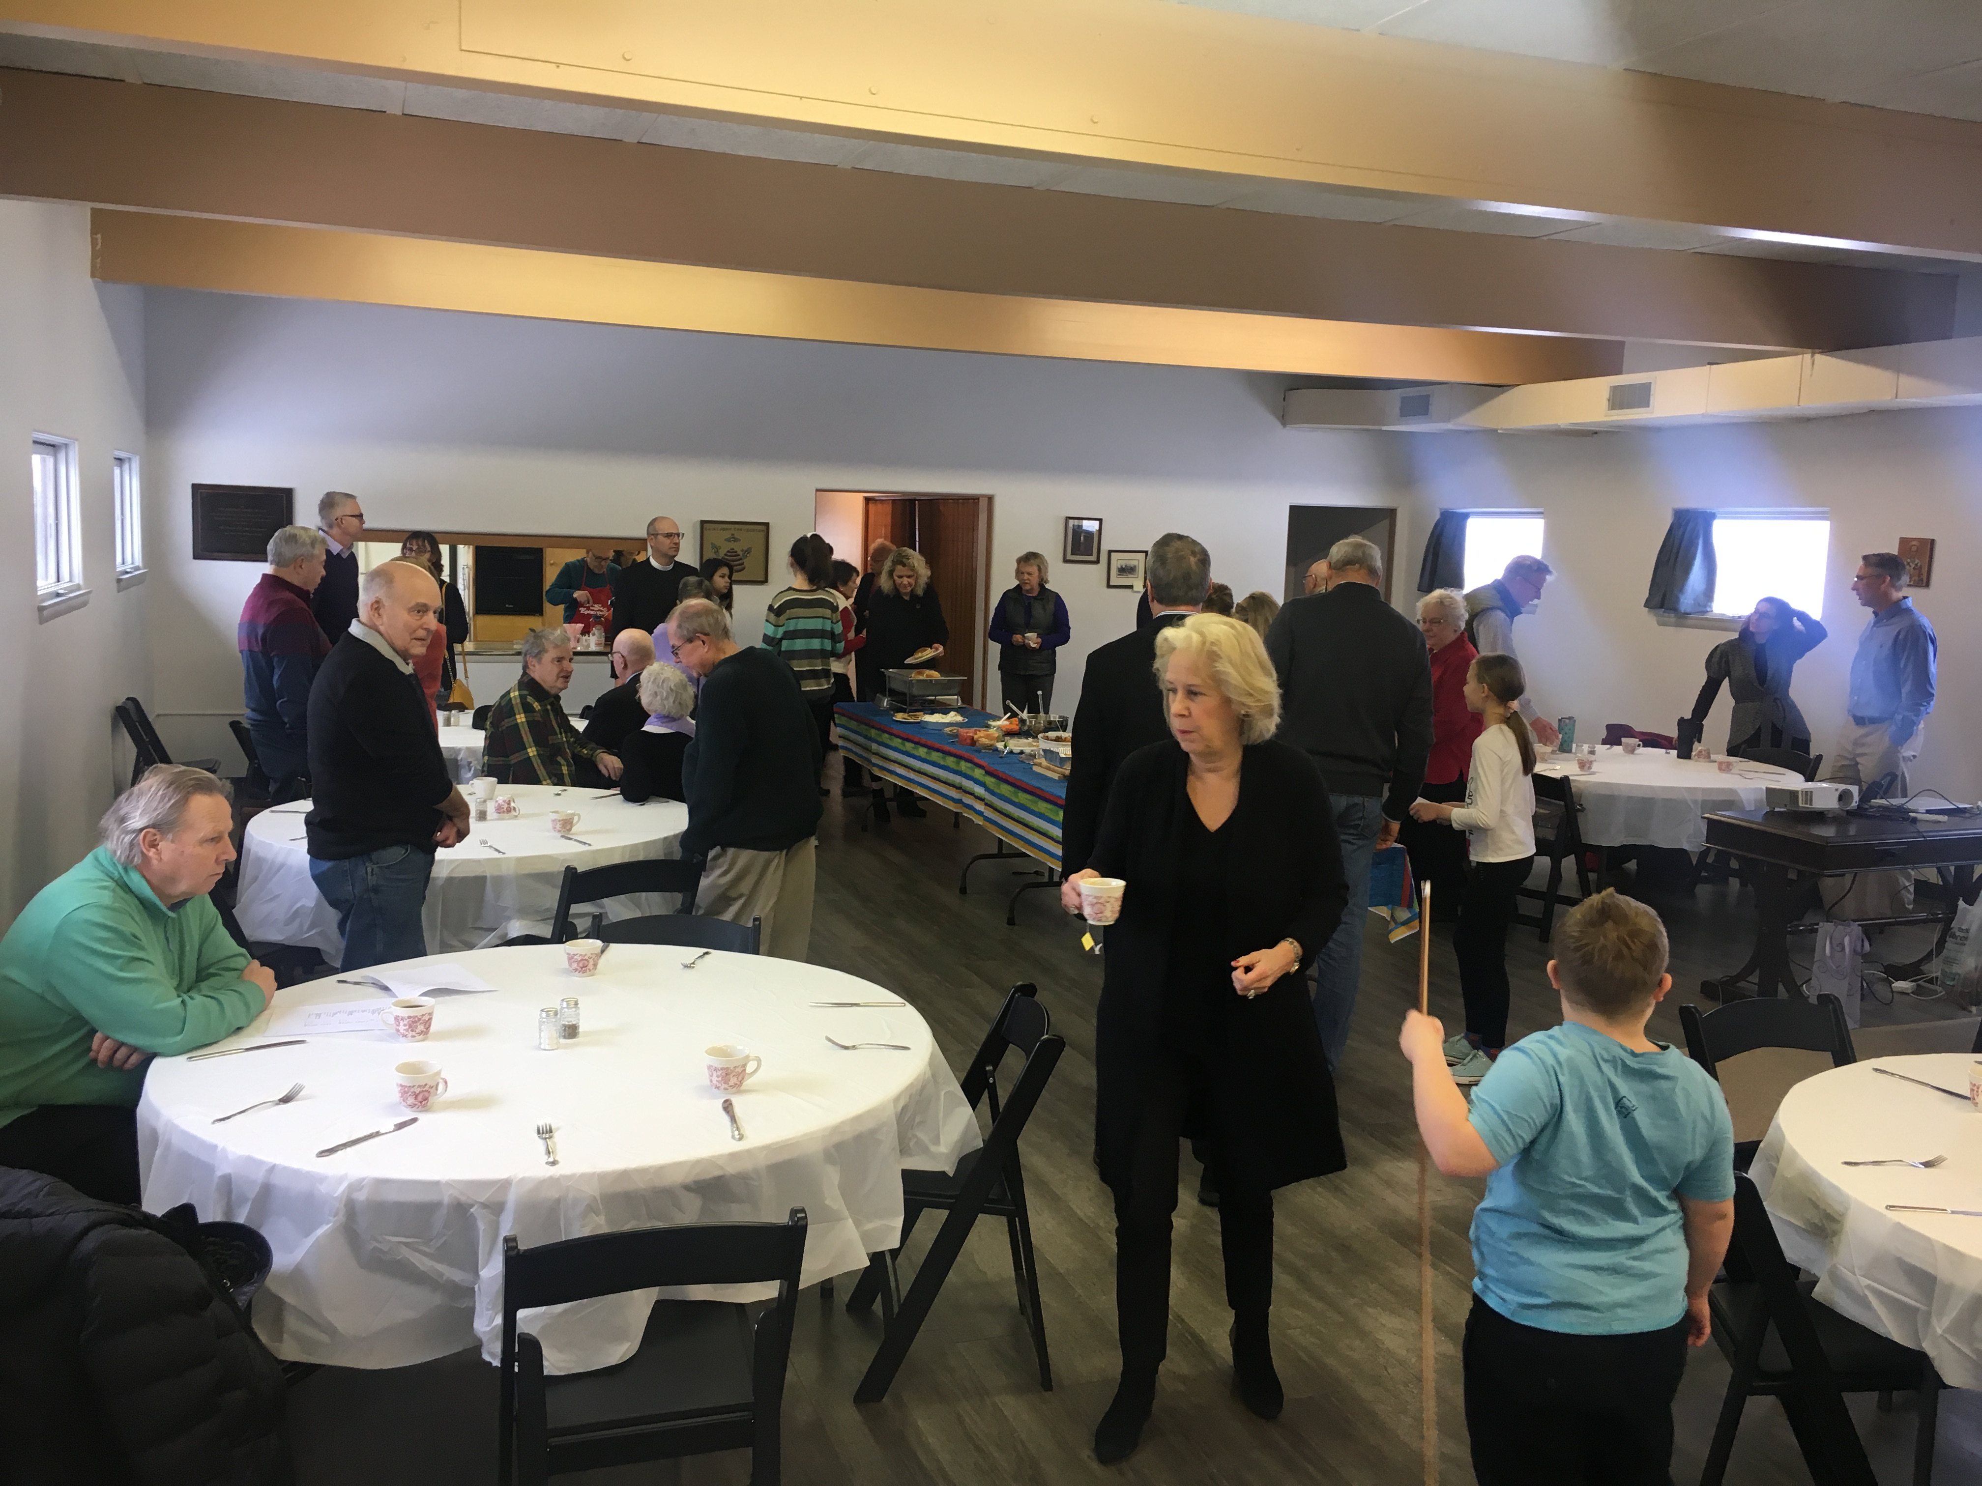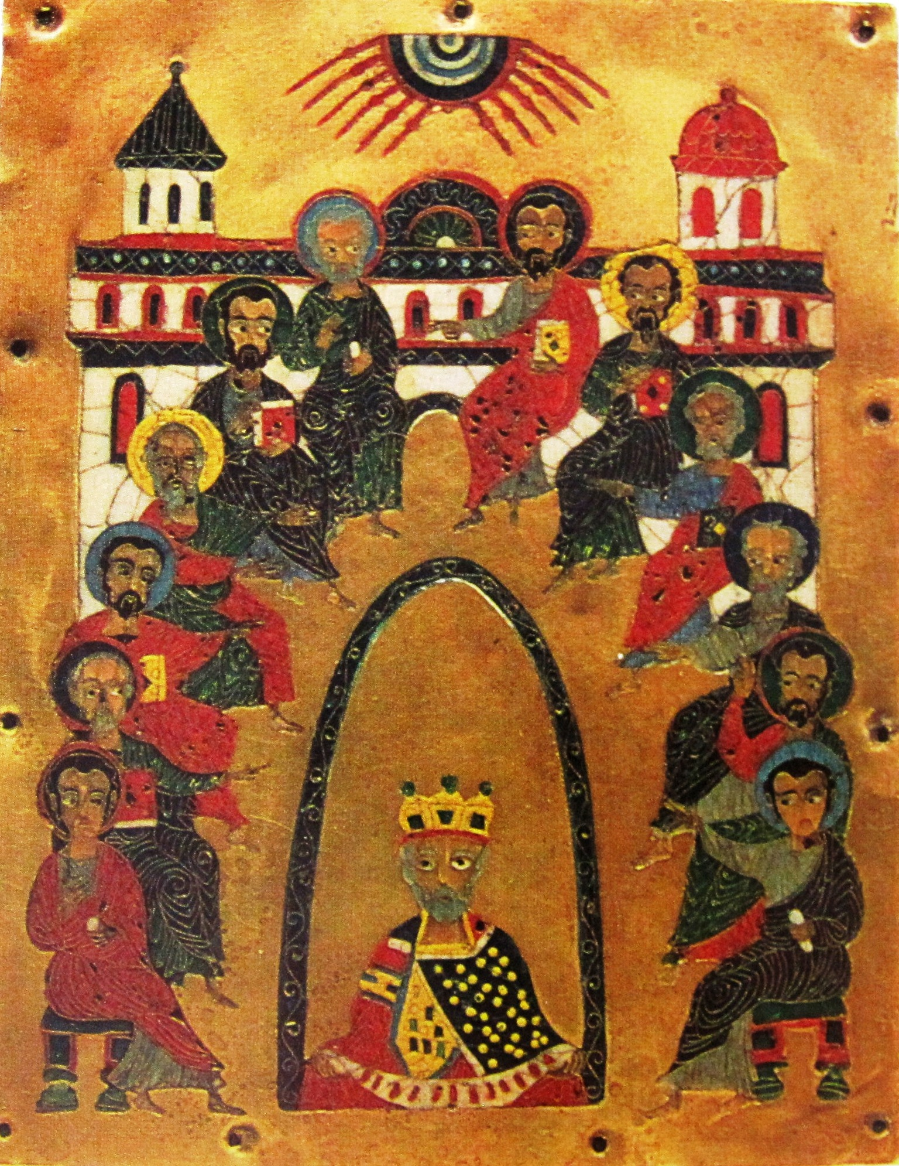

# Thoughts from your rector (Sometimes they are worth reading)

The Pioneer is a publication of St. John Chrysostom Episcopal Church in Delafield Wisconsin. It is published six times a year. If you have anything you would like to see in it, please contact the Church Office at (262) 646-2727

March - April 2019

Issue 2

The pioneer

In this Issue

Page 2: 2Tue2 - The lecture series about which everyone is talking

Page 3: Annual Meeting

Page 4: Sunday School for the Spring

I am currently reading a book called The Power of Habit: Why We Do What We Do in Life and Business by Charles Duhigg. And while the title may overpromise a bit (because honestly I do not feel that I now understand everything about my motivations and action) it does offer some interesting insights about the patterns that emerge in our lives. The author’s model through which everything is filtered is something called the habit loop. What this is in practicality is a three-step model containing the following component: a cue, which is followed by an action and ends with a reward. So for example you felt hungry, you go eat something and as a result you are rewarded by no longer feeling hungry. The model itself is neutral, that is it does not promote good or bad behaviors. So in the case of feeling hungry you might eat a salad or you might eat an entire pecan pie. The trick, the author argues, is to figure out the cues and determine a healthy way to get to the reward.

It would seem that we are living in times where the habit loop is working quite well, but the action part of it is, in many cases, promoting something very unhealthy. If you think about the heroin epidemic that is so prevalent right now, the cue most likely is some feeling that all is not right. Perhaps the person feels lonely or afraid and takes the drug to mask those feelings and temporarily replace them with more euphoric feelings. But like eating the entire pecan pie, the action used to achieve the (continued on page 3) reward is ultimately destructive. And all of this, of course, leads me to the season of Lent – which, as you have heard me mention countless times before, is a season of examination.

We often think of Lent as looking in ourselves and asking what in us is not glorifying to God. And I want to suggest that maybe using this model of the habit loop may be a useful way to examine ourselves and our actions. It could help us in seeing why we do things that may not be glorifying to God and finding ways to replace those actions with things that achieve the same reward but without the sinfulness.

So ,for example, if I notice that when I am bored I call a friend of mine who then fills me in on the latest gossip the habit loop is this: Boredom leads to a call filled with gossip which leads to the reward of not being bored. However, in examining this it may point out to me that I need to find a better way to relieve boredom. Maybe instead of listening to gossip, I could read a selection from Introduction to the Devout Life by St. Francis de Sales (a good book, you should read it). I would still be rewarded by not being bored but I would also do something life affirming, something to help grow in love and grace.

I obviously do not know the habit loops that you may be stuck in, but it is worth an examination to see why we do what we do and if it could be replaced with something more glorifying to God.

Calendar of Events

* 1. Paul Borchardt, the Observatory Director for the Milwaukee Astronomical Society will give a presentation on the stars and our place in the cosmos. **Tuesday, April 9 at 2:00pm.**
* 2. Lenten Season Evening Prayer on Saturdays at 5:00pm starts March 9th and will go through Lent. As discussed at the Annual Meeting, this will be a relatively short service (30 minutes or so) followed by a small reception. We encourage you to come and bring friends, especially those with kids in sports who cannot make it on Sundays.

3. Acolyte Training. Saturday, March 9th at 3:30 PM in the Parish. If you have a child who would like to be an acolyte please have them attend this training. It will last about one hour.

4. Two of Nashotah House's medieval manuscripts are going to be part of an exhibit at the Milwaukee Art Museum. The exhibit is called The Art of Devotion: Illuminated Manuscripts from Local Collections. The manuscripts, which are part of the Underwood Prayer Book Collection, are The Book of Hours Sarum Use Manuscript, c. 1400 and The Boies Penrose II Decorated Manuscript, c. 1500.

Church Cleaning Schedule: Cleaning can be done on the Friday or Saturday

A Hotbed of Abolitionist Radicals

The Underground Railroad in Waukesha County

Who were the people who earned Waukesha this dubious title? Why & how did they support fugitive slaves in the 1840s & 50s?  Explore memoirs and other historical documents to learn about the local folks whose covert actions saved lives and challenged the status quo.

Please join us as we welcome Kimberly Redding, Associate Professor of History at Carroll University to discuss this intriguing topic.

St. John Chrysostom Parish Hall-1111 Genesee Street, Delafield, WI

262-646-2727 for more information.

2TUE2 is a free lecture series hosted by the parish of St. John Chrysostom in Delafield

The pioneer

reward is ultimately destructive. And all of this, of course, leads me to the season of Lent – which, as you have heard me mention countless times before, is a season of examination.

We often think of Lent as looking in ourselves and asking what in us is not glorifying to God. And I want to suggest that maybe using this model of the habit loop may be a useful way to examine ourselves and our actions. It could help us in seeing why we do things that may not be glorifying to God and finding ways to replace those actions with things that achieve the same reward but without the sinfulness.

So ,for example, if I notice that when I am bored I call a friend of mine who then fills me in on the latest gossip the

# Thoughts from your rector (Continued from Page 1)

habit loop is this: Boredom leads to a call filled with gossip which leads to the reward of not being bored. However, in examining this it may point out to me that I need to find a better way to relieve boredom. Maybe instead of listening to gossip, I could read a selection from Introduction to the Devout Life by St. Francis de Sales (a good book, you should read it). I would still be rewarded by not being bored but I would also do something life affirming, something to help grow in love and grace.

I obviously do not know the habit loops that you may be stuck in, but it is worth an examination to see why we do what we do and if it could be replaced with something more glorifying to God.

**Guild of St. Benedict Meeting at All Saints' Cathedral**

The next meeting of the Guild of St. Benedict is set for Thursday, March 7th.

It will begin with Evening Prayer at 6:15 pm (those who wish may come for the Holy Eucharist at 5:30 pm) at All Saints' Cathedral, 818 E. Juneau Ave., Milwaukee. All are welcome to participate, including sharing a meal together and attending the meeting.

The meeting will feature a special guest speaker, the Rev. Adam Bucko of the Diocese of Long Island. Deacon Bucko, a senior at Nashotah House, is a great student of monastic spirituality and has published three books, including The New Monasticism: A Manifesto for Contemplative Living.

Come join in for what will be a very good evening as we enter into Lent.

* Please let the planners know if you are coming so they can plan accordingly for dinner.
* Email Fr. Steve Peay at Steven.Peay@ASCathedral.org.
* 

Annual Meeting was a Great Success (or at least the food was really good)

At the annual meeting the budget for the year was presented and it is balanced. Also at the meeting we thanked Tom Schlaeffer for his dedication as Senior Warden. Melissa Erickson will take over Tom’s job and Eric Bay will serve as treasurer.

Sunday School in the New Year

Beginning in the February we will have a Newcomers Sunday School Series, created by Fr. Philip that is really for everyone. The weekly topics covered include:

In the Beginning - The Origin of Christianity

Judges, Kingdoms and Exile

Restoration and the time before the New Testament

Oh Come, Oh Come Emanuel

Unto us a Child is born

Christ the Lord is risen today

Acts of the Apostles

The Epistles and The Revelation

Stuff that did not make the Bible

Jerusalem, Samaria and the ends of the earth

Church Councils

Those Wacky Middle Ages

Reformation

The King's Great Matter

Bloody Mary to the Elizabethan Settlement

Anglicanism comes to America

How did the Episcopal Church get to Wisconsin?

The Recent Unpleasantness

March - April 2019

The pioneer